

LÁTKY KAPALNÉ, TUHÉ A PLYNNÉ

kliparty použity z galerie firmy Microsoft Word

<http://office.microsoft.com/cs-cz/images/results.aspx?qu=knihy&ex=2#ai:MC900019306|>

<http://office.microsoft.com/cs-cz/images/results.aspx?qu=ml%C3%A9ko&ex=1#ai:MP900321172|>

<http://office.microsoft.com/cs-cz/images/results.aspx?qu=pero&ex=1#ai:MC900441726|>

<http://office.microsoft.com/cs-cz/images/results.aspx?qu=hrnek&ex=1#ai:MC900441391|>

<http://office.microsoft.com/cs-cz/images/results.aspx?qu=n%C5%AF%C5%BEky&ex=1#ai:MC900370178|>

<http://office.microsoft.com/cs-cz/images/results.aspx?qu=konev&ex=1#ai:MC900406246|>

<http://office.microsoft.com/cs-cz/images/results.aspx?qu=h%C5%99eben&ex=1#ai:MC900325412|>

<http://office.microsoft.com/cs-cz/images/results.aspx?qu=ohe%C5%88&ex=1#ai:MC900014755|>

<http://office.microsoft.com/cs-cz/images/results.aspx?qu=propan&ex=1#ai:MC900320238|>

<http://office.microsoft.com/cs-cz/images/results.aspx?qu=pit%C3%AD&ex=1#ai:MC900232682|>

[http://office.microsoft.com/cs-cz/images/results.aspx?qu=voda&ex=1#ai:MP900400014|](http://office.microsoft.com/cs-cz/images/results.aspx?qu=voda&ex=1%23ai:MP900400014|)

Urči, co je na obrázku z látky tuhé, kapalné, plynné.

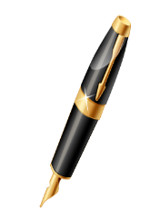 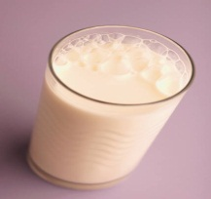 C:\Users\dudova\AppData\Local\Microsoft\Windows\Temporary Internet Files\Content.IE5\HFUSV5EM\MC900019306[1].wmf 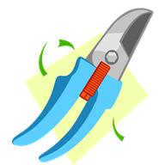 C:\Users\dudova\AppData\Local\Microsoft\Windows\Temporary Internet Files\Content.IE5\V8KNT36V\MC900406246[1].wmf

C:\Users\dudova\AppData\Local\Microsoft\Windows\Temporary Internet Files\Content.IE5\HFUSV5EM\MC900325412[1].wmf C:\Users\dudova\AppData\Local\Microsoft\Windows\Temporary Internet Files\Content.IE5\240BZG06\MC900014755[1].wmf C:\Users\dudova\AppData\Local\Microsoft\Windows\Temporary Internet Files\Content.IE5\HFUSV5EM\MC900320238[1].wmf 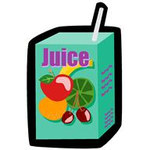 

Řešení úkolu :

kakao, mléko, voda, džus

pero, knihy, zahradnické nůžky, konev s rýčem, hřeben

plynový hořák, plynová bomba