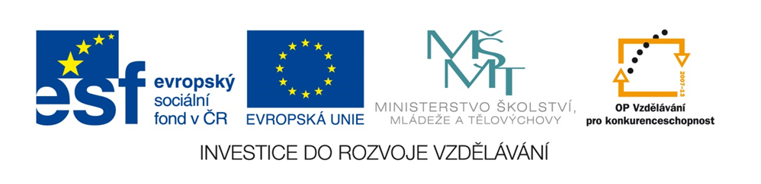

Otázky

Pracovní list

Podle odpovědi napiš nebo doplň otázku.

I am Anna.

This is my mum.

I live in Ořechov.

This is his new bag.

It is your small pen.
Řešení

What is your name?

I am Anna.

Who is this?

This is my mum.

Where do you live?

I live in Ořechov.

What is this?

This is his new bag.
What is it?

It is your small pen.

