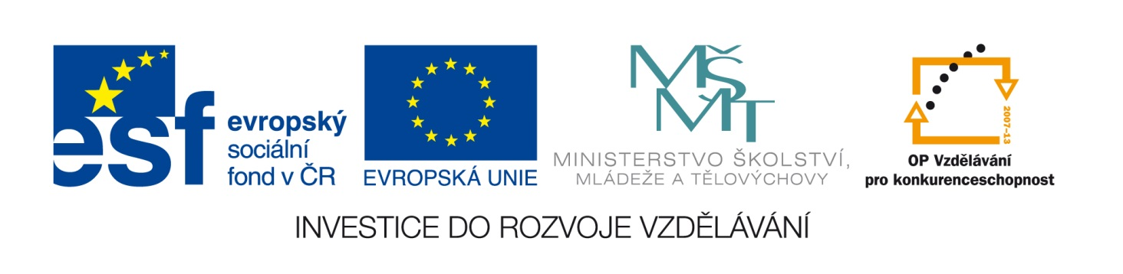

**ABECEDA**

Použité zdroje:

<http://office.microsoft.com/cs-cz/images/results.aspx?qu=kapka&ex=1#ai:MP900400015> [http://office.microsoft.com/cs-cz/images/results.aspx?qu=beruška&ex=1#ai:MC900337898](http://office.microsoft.com/cs-cz/images/results.aspx?qu=beru%C5%A1ka&ex=1#ai:MC900337898)

[http://office.microsoft.com/cs-cz/images/results.aspx?qu=autosedačka&ex=1#ai:MC900338112](http://office.microsoft.com/cs-cz/images/results.aspx?qu=autoseda%C4%8Dka&ex=1#ai:MC900338112) <http://office.microsoft.com/cs-cz/images/results.aspx?qu=auto&ex=1#ai:MC900398461>

[http://office.microsoft.com/cs-cz/images/results.aspx?qu=mušle&ex=1#ai:MC900438049](http://office.microsoft.com/cs-cz/images/results.aspx?qu=mu%C5%A1le&ex=1#ai:MC900438049) [http://office.microsoft.com/cs-cz/images/results.aspx?qu=salám&ex=1#ai:MC900413024](http://office.microsoft.com/cs-cz/images/results.aspx?qu=sal%C3%A1m&ex=1#ai:MC900413024)

<http://office.microsoft.com/cs-cz/images/results.aspx?qu=hodiny&ex=1#ai:MP900385402> [http://office.microsoft.com/cs-cz/images/results.aspx?qu=čáp&ex=1#ai:MC900411638](http://office.microsoft.com/cs-cz/images/results.aspx?qu=%C4%8D%C3%A1p&ex=1#ai:MC900411638)

<http://office.microsoft.com/cs-cz/images/results.aspx?qu=ruce&ex=1#ai:MP900411759> [http://office.microsoft.com/cs-cz/images/results.aspx?qu=flétna&ex=1#ai:MC900150953](http://office.microsoft.com/cs-cz/images/results.aspx?qu=fl%C3%A9tna&ex=1#ai:MC900150953)

<http://office.microsoft.com/cs-cz/images/results.aspx?qu=injekce&ex=1#ai:MC900279538> <http://office.microsoft.com/cs-cz/images/results.aspx?qu=kolo&ex=1#ai:MM900395710>

<http://office.microsoft.com/cs-cz/images/results.aspx?qu=opice&ex=1#ai:MP900449101> [http://office.microsoft.com/cs-cz/images/results.aspx?qu=tulipány&ex=1#ai:MP900448472](http://office.microsoft.com/cs-cz/images/results.aspx?qu=tulip%C3%A1ny&ex=1#ai:MP900448472)

[http://office.microsoft.com/cs-cz/images/results.aspx?qu=žába&ex=1#ai:MP900448634](http://office.microsoft.com/cs-cz/images/results.aspx?qu=%C5%BE%C3%A1ba&ex=1#ai:MP900448634) [http://office.microsoft.com/cs-cz/images/results.aspx?qu=mušle&ex=1#ai:MC900438049](http://office.microsoft.com/cs-cz/images/results.aspx?qu=mu%C5%A1le&ex=1#ai:MC900438049)

Seřaď obrázky podle abecedy. Která písmena zde nemají zastoupení? Vypiš je:

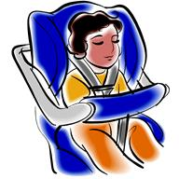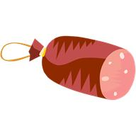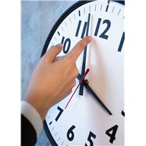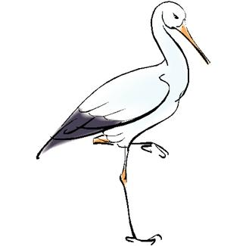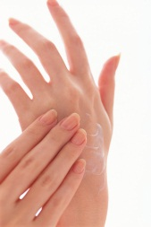C:\Users\martinakova.SKOLA\AppData\Local\Microsoft\Windows\Temporary Internet Files\Content.IE5\A4H08OS8\MC900150953[1].wmf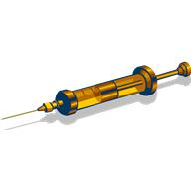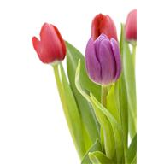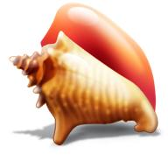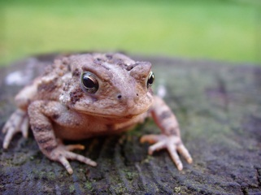C:\Users\martinakova.SKOLA\AppData\Local\Microsoft\Windows\Temporary Internet Files\Content.IE5\A4H08OS8\MC900337898[1].wmfC:\Users\martinakova.SKOLA\AppData\Local\Microsoft\Windows\Temporary Internet Files\Content.IE5\11OB6F9Y\MC900398461[1].wmf

ŘEŠENÍ:

C:\Users\martinakova.SKOLA\AppData\Local\Microsoft\Windows\Temporary Internet Files\Content.IE5\11OB6F9Y\MC900398461[1].wmfC:\Users\martinakova.SKOLA\AppData\Local\Microsoft\Windows\Temporary Internet Files\Content.IE5\A4H08OS8\MC900337898[1].wmf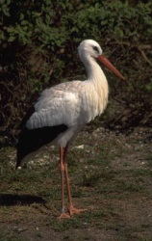C:\Users\martinakova.SKOLA\AppData\Local\Microsoft\Windows\Temporary Internet Files\Content.IE5\A4H08OS8\MC900150953[1].wmf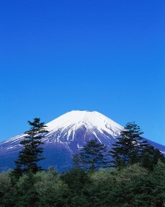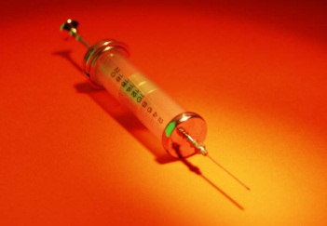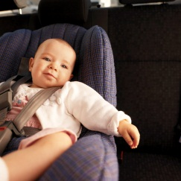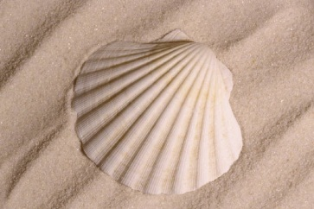C:\Users\martinakova.SKOLA\AppData\Local\Microsoft\Windows\Temporary Internet Files\Content.IE5\F14YA8UV\MC900088416[1].wmf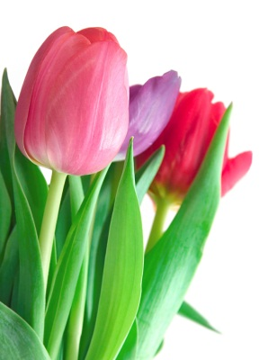 Chybí: c, d, ď, e, g, ch, j, , l, n, ň, p, q, ř, š, ť, u, w, x, y, z.