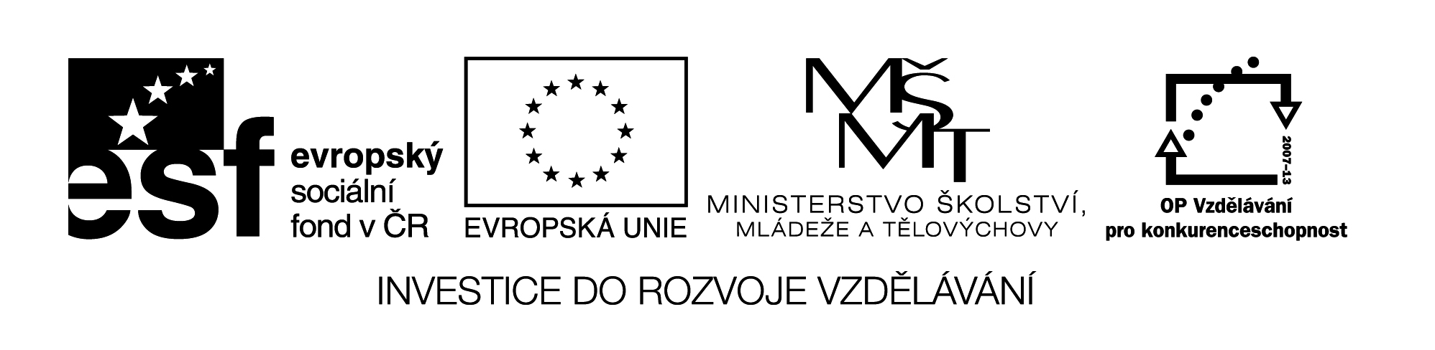

My funny body

Přiřaď anglické názvy částí těla.

head

eye

back

teeth
neck
tummy
hand
chest
finger
face
arm
foot
toe
mouth
nose
ear
leg
hair

Nakresli legrační tělo podle pokynů.

It has got big head.
It has got happy face.
It has got small pink mouth.
It has got long orange nose.
It has got short brown hair.
It has got big green ears.
It has got fat yellow tummy.
It has got thin pink neck.
It has got short blue arms.
It has got long black legs.
It has got big red toes.
It has got six fingers.
It has got small grey eyes.

My funny body - řešení

Přiřaď anglické názvy částí těla.

head

eye
hair
ear
face
nose

mouth
teeth
neck
back
arm

chest
finger
hand
tummy

leg

foot
toe

